PRESS RELEASE

A copy of the article would be appreciated

Number of characters: 208 Holdback: none

WISKA’s COMBI 206 makes the finals.
WISKA’s latest product (The COMBI 206) has been selected as a finalist for this year’s Electrical Industry Awards 2019.
The Electrical Industry Awards is an annual awards ceremony organised by Electrical Times Magazine, celebrating excellence and product innovation within the electrical industry. The COMBI 206 has been selected for Residential/ Domestic Product of the Year 2019.
The COMBI 206 is the smallest member of the COMBI junction box range measuring 85 x 49mm, approximately half the size of the COMBI 308 model. The COMBI 206 offers WISKA’s usual high Ingress Protection rating (IP66/67) as well as the user-friendly threaded membrane entry system (6 x M20 threaded entries and 2 rear membrane entries). The COMBI 206 comes complete with 3 x WAGO 221 3-conductor lever connectors. Available in black, light grey and white this clever little box is perfect for outside applications including video-surveillance systems and LED lighting, offering all the benefits of its COMBI 308 big brother, in a smaller solution. (The COMBI 206 can also be used with SWA Cable with the addition of a simple earthing solution).
The awards take place on Thursday 24th October at The Royal Garden Hotel, London.
For more information on the COMBI 206 visit www.wiska.co.uk

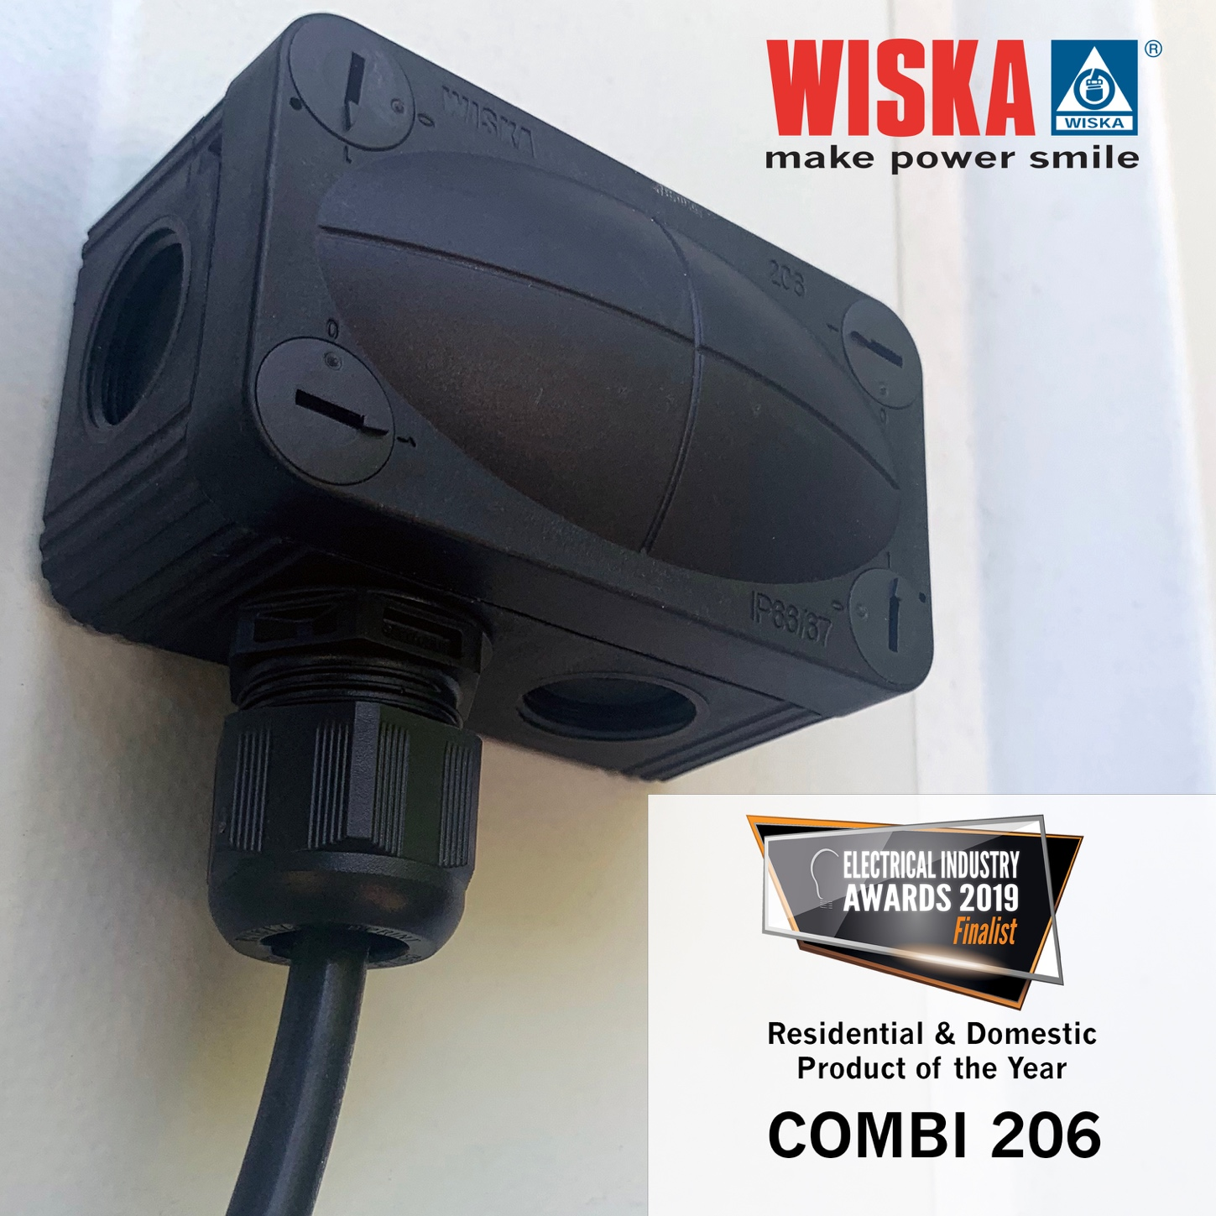
About WISKA
WISKA are the market leaders in the manufacture and supply of an innovative and quality range of cable entry systems, junction boxes and gel jointing products. WISKA was founded in Hamburg in 1919, and has been trading in the UK since 2000. WISKA operates its own research and development facilities and production plants in Germany, ensuring all products meet the highest standards in excellence. WISKA prides itself on offering quality solutions with friendly helpful service. WISKA, make power smile.
Press contact

WISKA UK
Elliott Rothon |  | Phone: |  | 01208 816062
Unit 7, Hurling Way, St Columb Major Business Park |  | Fax: |  | 01208 816708
St Columb Major |  | Mobil: |  | 07702 569572
Cornwall, TR9 6SX |  | Email: |  | e.rothon@wiska.co.uk
www.wiska.co.uk

