PRESS RELEASE
Press reprints free of charge. A copy of any article would be appreciated
Number of characters: 1.126 Holdback: none

WISKA presents polyamide EMC locknut
Particularly in the industrial environment, with increasingly complex technologies, there is a large number of components that must be effectively protected against electromagnetic interference. For cable entry, there are various solutions, mostly as earthing inserts or braids used in metal cable gland fittings. With its new MagikNUT, WISKA now presents a solution which easily establishes the cable shield contact via the locknut.
The MagikNUT is a new polyamide EMC locknut with an integrated stainless steel clip. The EMC installation is easy and quick: The approx. 1 cm stripped off shielded cable is contacted by the claws of the stainless steel clip within the locknut. In addition to the considerably simplified shield contacting, the MagikNUT polyamide design also enables a simple EMC solution for plastic cable glands: The user benefits from maximum flexibility, from standard cable glands to threaded membrane entries and conduit fittings for cable protection. The new WISKA locknut is lightweight, available in M16, M20 and M25 and black or grey. All information on wiska.com.

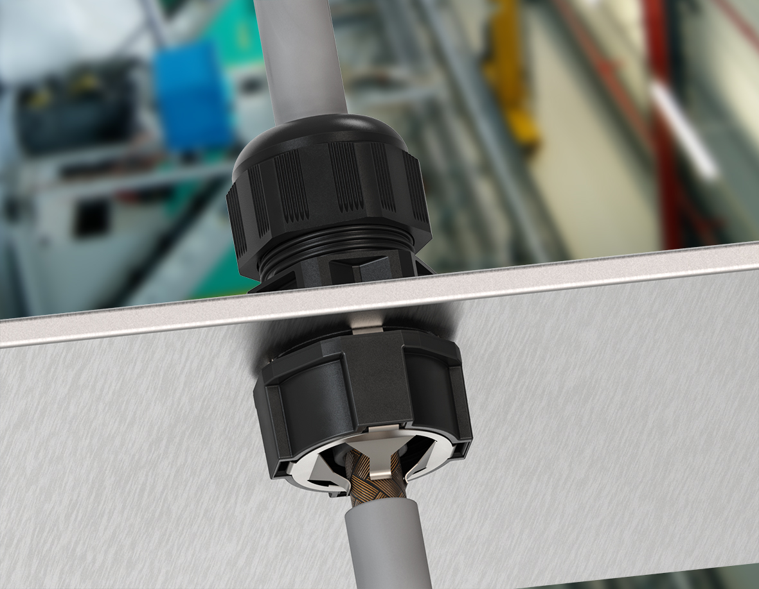
Picture subtitles:
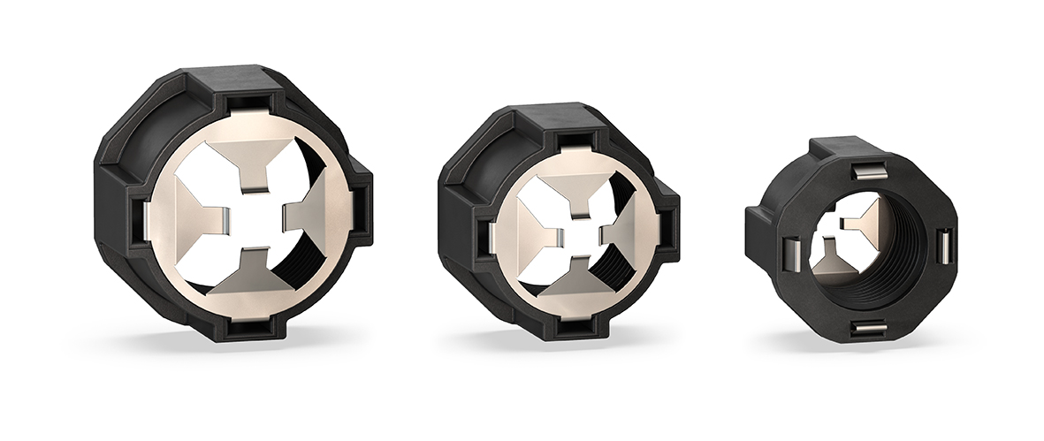

Pict. „WISKA-MagikNUT_Group“: Pict. „WISKA-MagikNUT_Installation“:
„The new WISKA polyamide EMC locknut: „EMC shield connection via locknut:
MagikNUT.“ MagikNUT by WISKA.“
Download: www.wiska.com/press
Weblink for products:
https://bit.ly/3jRG9jA
About WISKA®
Founded in Hamburg in 1919, we are today one of the leading manufacturers of electrical equipment, lighting products and CCTV video surveillance for trade, industry and shipbuilding. We operate our own research and development facilities and production plants next door at our headquarters in Germany. Our global sales network of representatives and subsidiaries ensure a quick and personal on-site customer service for you. The WISKA Group today employs 260 people worldwide. www.wiska.com
Tags
WISKA, EMC, polyamide, locknut, industry, electromagnetic compatibility, cable entry, earthing insert, cable gland, shield contact, stainless steel, plastic, design, installation, cable, conduit fitting, MagikNUT
Press contact
WISKA Hoppmann GmbH
Anja Lange Telefon: +49-4191-508-503
Kisdorfer Weg 28 Mobil: +49-174-9265212
24568 Kaltenkirchen, Germany a.lange@wiska.de

